Spray Machines recommended for Diathonite

PFT
recommended by Diasen
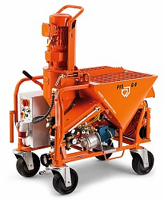 | 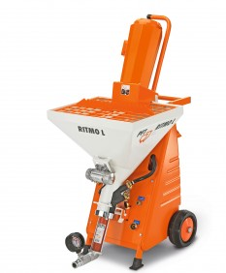
PFT G4 | PFT Ritmo L

MTEC-330

PUTZMEISTER SP-11

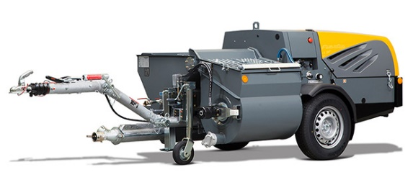

* Please refer to the manufacturers of the machines for recommended settings

